Department of Veterans Affairs (VA)   
  
Benefits Claims Decision Support System (BCDSS)  
  
User Guide

**VA118-1015-0036  
CLIN: 0004AA**



**June 27, 2016  
Version 0.1**

Revision History

|  |  |  |  |  |
| --- | --- | --- | --- | --- |
| Date | Version | Description | Author | Reviewer(s) |
| 2016-04-20 | 0.1 | Created BCDSS template. | E Rothwell |  |
| 2016-06/29 | 0.2 | Updated BCDSS specifics till date details | CJ Puttaswamy | Rebecca Garcia De Jesus |

Table of Contents

Purpose of this document 5

Welcome to BCDSS 5

Getting Started 5

Workstation Settings 5

Related Tasks 5

Understanding Permission Levels 5

Requesting a BCDSS User Account 6

Understanding Session Termination 6

Login into the Application 6

User Interface Features 7

Dashboard 7

Approval Signatures 9

# Purpose of this document

This document provides guidance in the use of the BCDSS application for all user roles. The User Manual lists the steps required by the Rater and the Modeling Agent to manage the application and perform claim related tasks. The use of the BCDSS system as the Administrator has been described in the BCDSS System Administrator Guide.

## Welcome to BCDSS

This user guide is a print version of the BCDSS Online Help, which can be accessed anytime from the BCDSS application by clicking the “Help” link on the top right corner of the home page.

# Getting Started

Before you can use the Benefits Claims Decision Support System (BCDSS), you must request and receive a BCDSS user name and password. See Requesting a BCDSS User Account for instructions.

### Workstation Settings

BCDSS is designed to be viewed with Internet Explorer (IE) 11.0 at a minimum screen resolution of 1024x768 and the default Medium text size. (The medium text size can be set from the IE menu bar with the option ***View > Text > Medium****)*. In addition, BCDSS is best viewed with a 4:3 standard-sized monitor (A widescreen monitor is also acceptable.)

### Related Tasks

See the following related topics to started using BCDSS:

* Logging into the Application
* Understanding Permission Levels
* Understanding Session Termination

Getting Additional Help

For additional help using the BCDSS application, contact the BCDSS Team at:

**Phone**: TBD

**Email**: TBD

## Understanding Permission Levels

The BCDSS permission levels are described in the following **BCDSS Permissions** matrix. The C*,* R, U, and D acronyms used in the figure denote Create, Read, Update, and Delete.

|  |  |  |  |  |
| --- | --- | --- | --- | --- |
| **Roles and Permissions** | | | | |
| **Permissions** | **Action** | **Rater** | **Modeling Agent** | **Administrator** |
| Dashboard | R | **Y** | **Y** |  |
| Run Model | R | **Y** | **Y** |  |
| Results View | R | **Y** | **Y** |  |
| Reports View | R | **Y** | **Y** |  |
| Manage Model | U |  | **Y** |  |
| Edit Model | U |  | **Y** |  |
| Manage Users | C, R, U, D |  |  | **Y** |
| User Permissions | U |  |  | **Y** |

## Requesting a BCDSS User Account

Rating specialists and Modelling Agents could request access to BCDSS application to the BCDS Administrator.

## Understanding Session Termination

The BCDSS adheres to the Veterans Affairs (VA) security policy of terminating a user session after a period of 60 minutes of inactivity. You will receive a two-minute warning before your session terminates.

If your session does time out, you will be redirected to the Login screen to log into BCDSS again. You should note that you will be directed to the BCDSS Homepage screen the next time you log into BCDSS, not to the location where you last were when your session ended.

## Login into the Application

To log into BCDSS, perform the following steps from your browser’s address bar:

Navigate to the BCDSS login screen shown below appear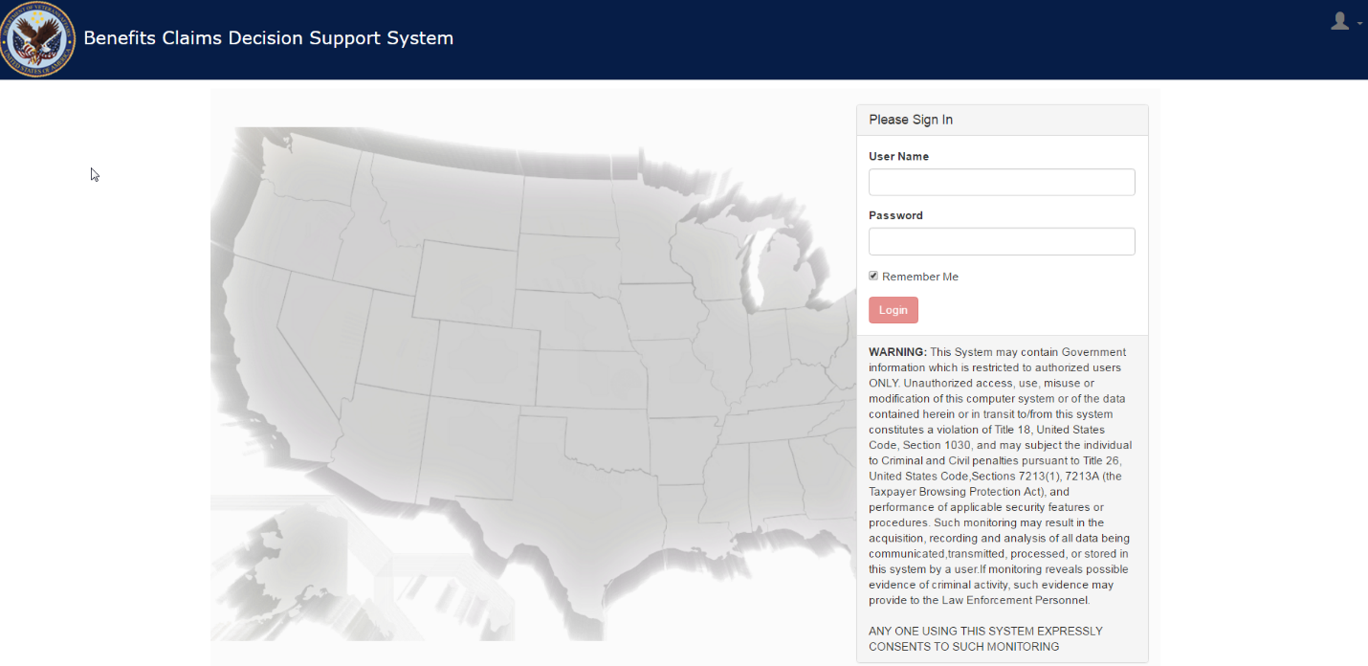

* + Enter your user name in the Username field.
  + Enter your password in the Password field.
  + Click Login button. The BCDSS home page appears. For more information, see The Home Page.

# User Interface Features

The BCDSS application uses tabbed pages to group the different functional elements of the application. The page is the top-level organizing element in the application, and within this page are tabs that organize the features of the application by functional areas.

The pages of the application are:

1. Dashboard (Home)
2. Result
3. Reports

## Dashboard

The following section describes elements of the BCDSS user interface and a few special pop-up tools that appear as you use the interface: These screen captures are examples for illustrative purposes and may differ slightly from the screens that you are viewing in the application.

**Screen Captures**

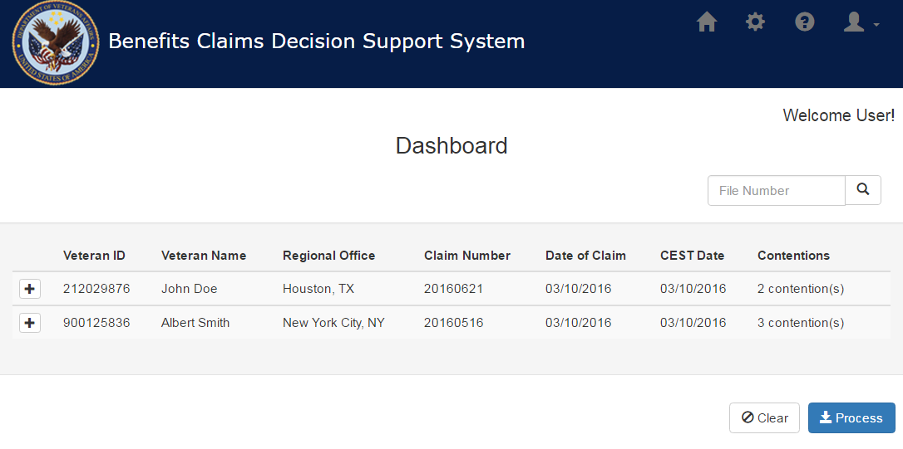

Figure 1: Home (Dashboard)

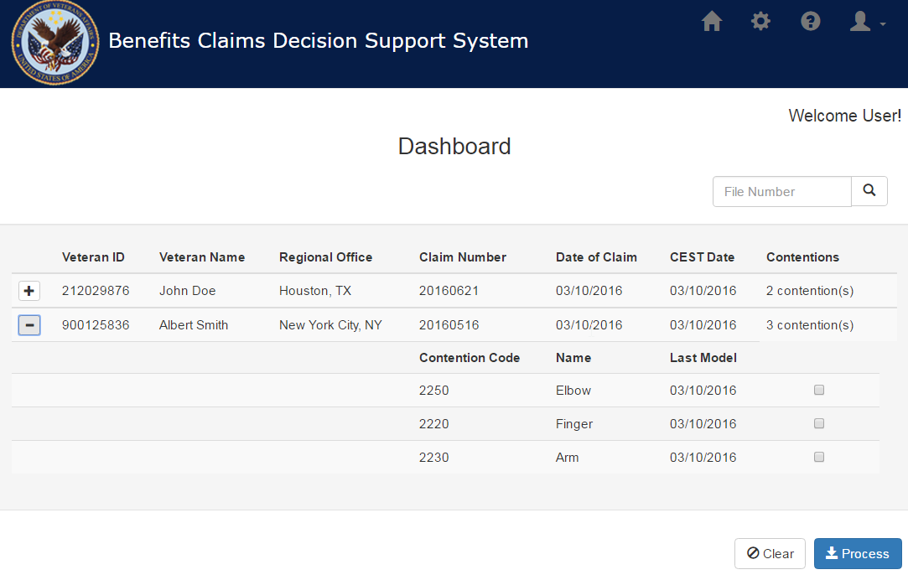

Figure 2 Dashboard Claims expanded view

# Approval Signatures

|  |  |  |
| --- | --- | --- |
| This section is used to document the approval of the User Guide Document. The review should be conducted face to face where signatures can be obtained ‘live’ during the review. If unable to conduct a face-to-face meeting, then it should be held via LiveMeeting and concurrence captured during the meeting. The Scribe should add /es/name by each position cited. Example provided below.  The Business Sponsor and Project Manager are required to sign.  ______________________________________________________________________________  Signed: Date:  < Business Sponsor >  ______________________________________________________________________________  Signed: Date:  < Project Manager > | |  |
|  |  |  |